• Single Responsibility Principle – Controllers handle API requests, Services contain business logic, and Repositories handle DB operations.
• Open Closed Principle – We used strategy pattern for payment processing so new payment types can be added without modifying existing code.
• Liskov Substitution Principle – Our notification services (Email, SMS, Push) implement the same interface and can replace each other without affecting the system.
• Interface Segregation Principle – We split large interfaces into smaller ones like Readable, Writable etc.
• Dependency Inversion Principle – We rely on interfaces and use Spring Dependency Injection to inject implementations.

You can say:
In our Spring Boot microservices architecture we apply SOLID principles at different layers. Controllers handle API responsibilities, services contain business logic, and repositories handle persistence which follows Single Responsibility Principle. For extensibility we use interfaces like PaymentProcessor so new payment methods can be added without modifying existing code, which follows Open Closed Principle. Implementations such as EmailNotification or SMSNotification follow Liskov Substitution since they can replace each other. We also break large interfaces into smaller ones to follow Interface Segregation, and we rely on Spring Dependency Injection to implement Dependency Inversion.

Here is a simple Microservices + Spring Boot architecture diagram showing where each SOLID principle is applied in a real project.

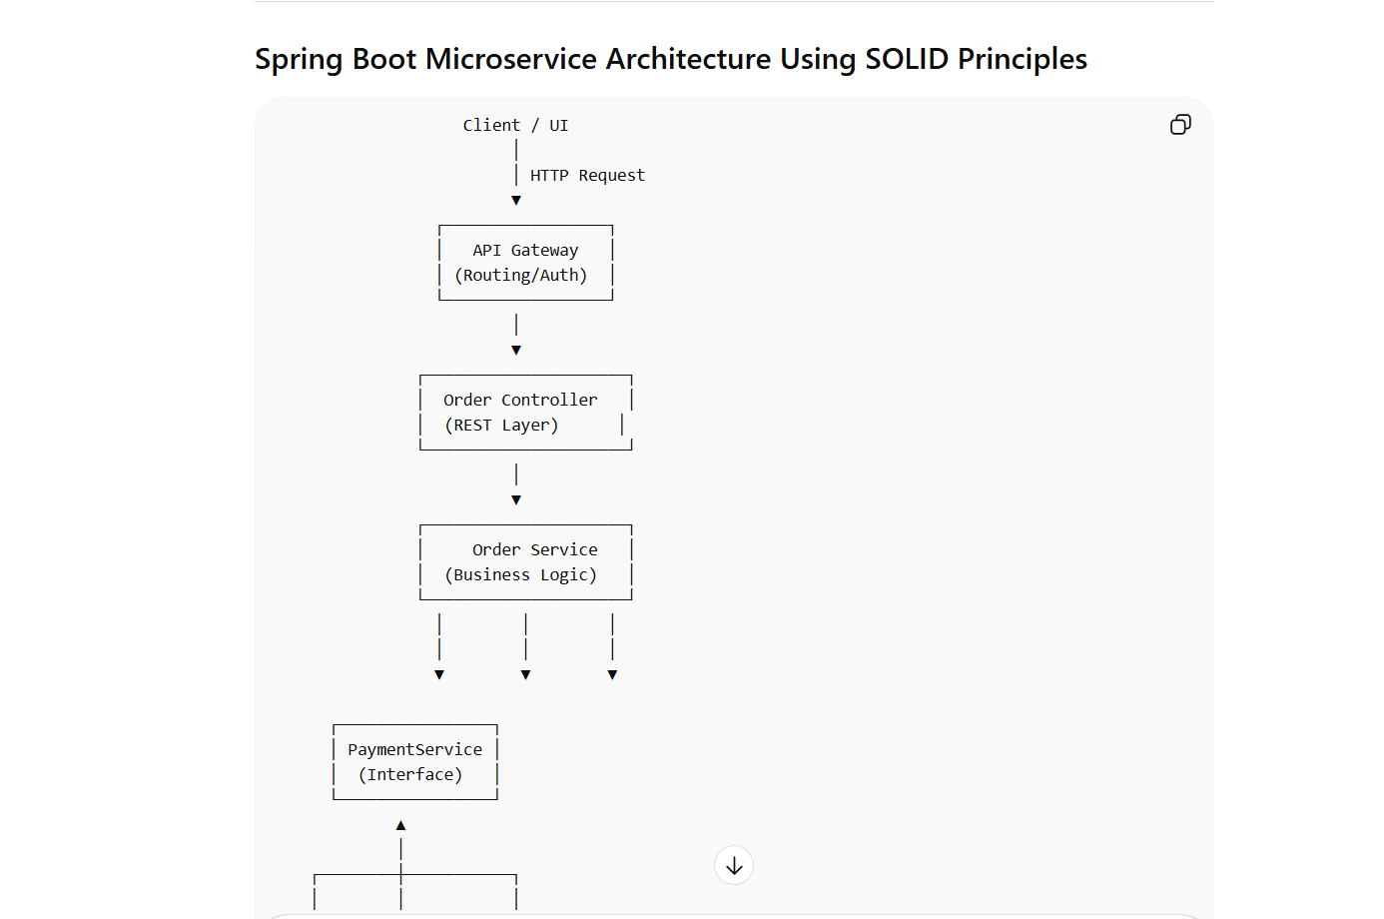

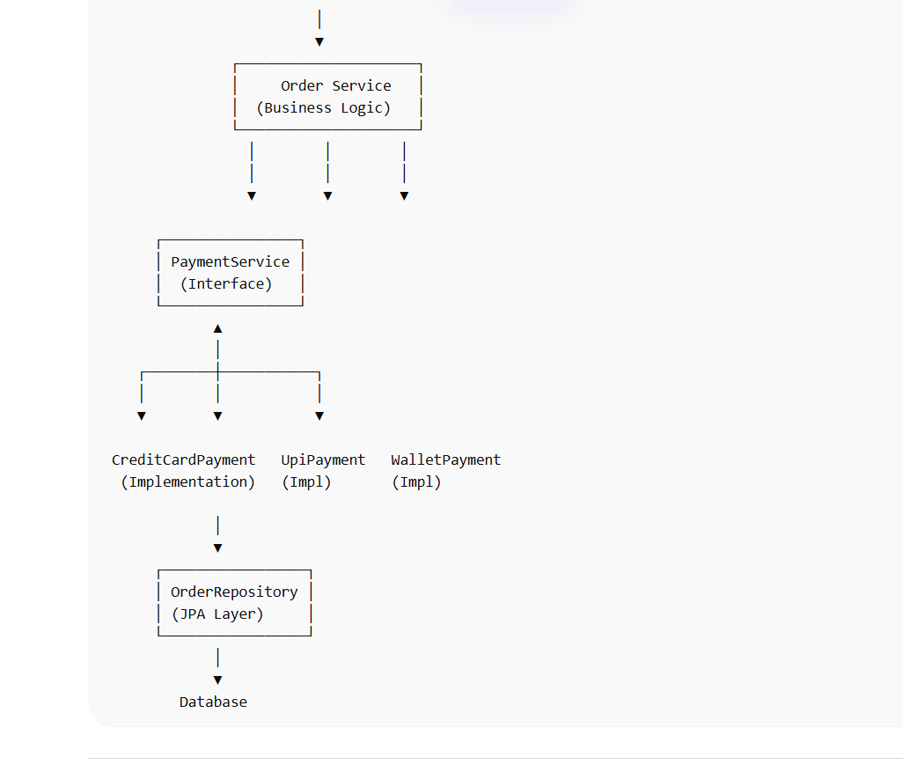



Spring Boot Microservice Architecture Using SOLID Principles
Client / UI
│
│ HTTP Request
▼
┌─────────────────┐
│ API Gateway │
│ (Routing/Auth) │
└─────────────────┘
│
▼
┌─────────────────────┐
│ Order Controller │
│ (REST Layer) │
└─────────────────────┘
│
▼
┌─────────────────────┐
│ Order Service │
│ (Business Logic) │
└─────────────────────┘
│ │ │
│ │ │
▼ ▼ ▼
┌────────────────┐
│ PaymentService │
│ (Interface) │
└────────────────┘
▲
│
┌────────┼───────────┐
│ │ │
▼ ▼ ▼
CreditCardPayment UpiPayment WalletPayment
(Implementation) (Impl) (Impl)
│
▼
┌─────────────────┐
│ OrderRepository │
│ (JPA Layer) │
└─────────────────┘
│
▼
Database

Where Each SOLID Principle Is Used
1️⃣ Single Responsibility Principle (SRP)
Each layer has one job.
Component | Responsibility
Controller | Handle HTTP requests
Service | Business logic
Repository | Database interaction
Example:
OrderController → API handling
OrderService → Order business rules
OrderRepository → DB operations
So each class changes for only one reason.

2️⃣ Open Closed Principle (OCP)
Payment system example:
PaymentService
│
▼
PaymentProcessor (Interface)
│
┌────┼───────────────┐
▼ ▼ ▼
CreditCardPayment UpiPayment WalletPayment
If tomorrow we add:
PayPalPayment
CryptoPayment
We add new classes without modifying existing code.

3️⃣ Liskov Substitution Principle (LSP)
All implementations must behave like the interface.
Example:
NotificationService
│
┌────┼───────────────┐
▼ ▼ ▼
EmailNotification SMSNotification PushNotification
System can replace:
NotificationService notification = new EmailNotification();
with
NotificationService notification = new SMSNotification();
Application still works.

4️⃣ Interface Segregation Principle (ISP)
Instead of large interfaces:
Bad Design
FileProcessor
├ read()
├ write()
├ compress()
├ encrypt()
Better design:
Readable
Writable
Compressible
Encryptable
Classes implement only what they need.

5️⃣ Dependency Inversion Principle (DIP)
High-level classes depend on interfaces, not implementations.
Example in Spring:
OrderService
│
▼
PaymentProcessor (Interface)
│
▼
CreditCardPayment
Spring injects dependency automatically.
Example:
@Service
class OrderService {
private final PaymentProcessor paymentProcessor;
public OrderService(PaymentProcessor paymentProcessor) {
this.paymentProcessor = paymentProcessor;
}
}
Spring injects:
CreditCardPayment
UPIPayment
WalletPayment

How This Looks in Real Enterprise Projects
In a typical banking / fintech microservice:
Controller Layer → SRP
Service Layer → SRP
Repository Layer → SRP
Strategy Pattern → OCP
Interface Implementations → LSP
Small Interfaces → ISP
Spring Dependency Injection → DIP

Interview Answer (Very Strong)
You can say:
In our Spring Boot microservices architecture we apply SOLID principles at different layers. Controllers handle API responsibilities, services contain business logic, and repositories handle persistence which follows Single Responsibility Principle. For extensibility we use interfaces like PaymentProcessor so new payment methods can be added without modifying existing code, which follows Open Closed Principle. Implementations such as EmailNotification or SMSNotification follow Liskov Substitution since they can replace each other. We also break large interfaces into smaller ones to follow Interface Segregation, and we rely on Spring Dependency Injection to implement Dependency Inversion.

✅ If you'd like, I can also show you a complete Banking System example that demonstrates ALL SOLID principles together.
This is one of the best examples for Java 8–12 year experience interviews and makes the concept extremely

where did you use these SOLID Principles in your project?
This is a very common senior Java interview question:
“Where did you use SOLID principles in your project?”
Interviewers expect practical examples from real systems, not textbook definitions.
Since you work with Java / Spring Boot / Microservices, you can answer like this.

1️⃣ Single Responsibility Principle (SRP)
Idea
Each class should do only one job.
Example from a Spring Boot project
In a typical microservice we separate:
Controller → Handle HTTP request
Service → Business logic
Repository → Database operations
Example:
@RestController
class OrderController {
@Autowired
OrderService orderService;
@PostMapping("/orders")
public Order createOrder(@RequestBody OrderRequest req) {
return orderService.createOrder(req);
}
}
Service:
@Service
class OrderService {
public Order createOrder(OrderRequest req) {
// business logic
}
}
Repository:
@Repository
interface OrderRepository extends JpaRepository<Order, Long> {
}
Each class has one responsibility:
Layer | Responsibility
Controller | API handling
Service | Business logic
Repository | Database
This follows SRP.

2️⃣ Open Closed Principle (OCP)
Idea
Classes should be open for extension but closed for modification.
Real Example: Payment System
In one project we had multiple payment methods.
PaymentProcessor
├ CreditCardPayment
├ UPIPayment
└ WalletPayment
Interface:
public interface PaymentProcessor {
void processPayment(double amount);
}
Implementations:
@Component
class CreditCardPayment implements PaymentProcessor {
public void processPayment(double amount) {
System.out.println("Processing credit card payment");
}
}
@Component
class UpiPayment implements PaymentProcessor {
public void processPayment(double amount) {
System.out.println("Processing UPI payment");
}
}
Service:
@Service
class PaymentService {
public void pay(PaymentProcessor processor) {
processor.processPayment(1000);
}
}
If we add PayPal, we only create:
class PaypalPayment implements PaymentProcessor
No existing code changes → OCP satisfied.

3️⃣ Liskov Substitution Principle (LSP)
Idea
Child classes should work wherever parent class is used.
Example from Notification Service
Interface:
public interface NotificationService {
void send(String message);
}
Implementations:
class EmailNotification implements NotificationService {
public void send(String message) {
System.out.println("Sending Email: " + message);
}
}
class SmsNotification implements NotificationService {
public void send(String message) {
System.out.println("Sending SMS: " + message);
}
}
Usage:
NotificationService notification = new EmailNotification();
notification.send("Order placed");
We can replace with:
NotificationService notification = new SmsNotification();
Application still works → LSP satisfied.

4️⃣ Interface Segregation Principle (ISP)
Idea
Avoid fat interfaces.
Example from File Processing
Bad design:
interface FileProcessor {
void read();
void write();
void compress();
}
Some classes do not need all methods.
Better design:
interface Readable {
void read();
}
interface Writable {
void write();
}
interface Compressible {
void compress();
}
Implementation:
class FileReader implements Readable {
public void read() {}
}
Now classes only implement what they need.

5️⃣ Dependency Inversion Principle (DIP)
Idea
Depend on interfaces, not implementations.
Example in Spring Boot (very common)
Service depends on interface.
@Service
class OrderService {
private final PaymentProcessor paymentProcessor;
public OrderService(PaymentProcessor paymentProcessor) {
this.paymentProcessor = paymentProcessor;
}
public void placeOrder() {
paymentProcessor.processPayment(1000);
}
}
Spring injects implementation automatically.
@Component
class CreditCardPayment implements PaymentProcessor {}
This is Dependency Injection, which implements DIP.

🎯 Perfect Interview Answer (Short Version)
You can say:
In our Spring Boot microservices project we follow SOLID principles.
For example:
• Single Responsibility Principle – Controllers handle API requests, Services contain business logic, and Repositories handle DB operations.
• Open Closed Principle – We used strategy pattern for payment processing so new payment types can be added without modifying existing code.
• Liskov Substitution Principle – Our notification services (Email, SMS, Push) implement the same interface and can replace each other without affecting the system.
• Interface Segregation Principle – We split large interfaces into smaller ones like Readable, Writable etc.
• Dependency Inversion Principle – We rely on interfaces and use Spring Dependency Injection to inject implementations.

✅ Pro Tip (For Senior Engineers)
Interviewers love hearing this sentence:
“Spring Framework itself heavily follows SOLID principles, especially Dependency Inversion through Dependency Injection.”

If you want, I can also show you something extremely useful for interviews:
A full Spring Boot architecture diagram showing where all SOLID principles are applied in a real microservices project.
Many 8–12 year Java interviews ask this.

